**INTRODUCTION TO DATA MANAGEMENT PROJECT**

(Project Semester August-December 2020)

# CRIMES IN INDIA



**Submitted by :**

Name :- Naveen Kumar Potta

Registration number:- 11802980

Section:- KM074

Course code:- INT217

B.Tech (Computer Science & Technology)

Under the Guidance of

**Komal Arora: 17783**

**Discipline of CSE/IT**

**Lovely School of Computer Science and Engineering**

**Lovely Professional University, Phagwara**

## **CERTIFICATE**

This is to certify that **Naveen Kumar Potta** bearing Registration no.

**11802980** has completed **INT217** project titled, **“Crimes In India”** under my guidance and supervision. To the best of my knowledge, the present work is the result of his/her original development, effort and study.

### **Signature and Name of the Supervisor**

### **Designation of the Supervisor**

### **School of Computer Science & Technology**

Lovely Professional University

Phagwara, Punjab

Date :-01-12-2020

## **DECLARATION**

I, **Naveen Kumar Potta**, student of Computer Science under CSE/IT Discipline at, Lovely Professional University, Punjab, hereby declare that all the information furnished in this project report is based on my own intensive work and is genuine.

Date:01-12-2020 Signature Registration No.11802980 *Naveen Kumar Potta*

**ACKNOWLEDGEMENT**

I hereby express my heartiest thanks to all the sources who have contributed to the making of this project. I oblige thanks to all those who have supported, provided their valuable guidance and helped for the accomplishment of this project. I also extend my hearty thanks to my family, friends, college teachers, and all the well-wishers.

I also would like to thanks my project guide **Komal Arora** for her guidance and timely suggestion and the information provided by his on this particular topic.

It is a matter of atmost pleasure to express my indebt and deep sense of gratitude to various people who extended their maximum help to supply the necessary information for the present thesis, which became available on account of the most selfless cooperation.

Above all its sincere thanks to the **LOVELY PROFESSIONAL UNIVERSITY** for

which this project is given consideration and was done with utmost seriousness.

# TABLE OF CONTENT

**Sl.No. Title**

1. Introduction & Objectives
2. Source of dataset
3. ETL process
4. Analysis of datasheet
   1. Introduction
   2. General Description
   3. Visualization
   4. Analysis results
   5. Specific requirements (Function and formula)
5. List of analysis with results
6. Future Scope
7. References/Bibliography

**INTRODUCTION :-**

Crime in [India](https://en.wikipedia.org/wiki/India) has been recorded since the [British Raj](https://en.wikipedia.org/wiki/British_Raj), with comprehensive statistics now compiled annually by the [National Crime Records Bureau](https://en.wikipedia.org/wiki/National_Crime_Records_Bureau)(NCRB), under the [Ministry of Home Affairs (India)](https://en.wikipedia.org/wiki/Ministry_of_Home_Affairs_(India))(MHA).

Crime in India is very common and happens in many different ways. Along with [violent crimes](https://simple.wikipedia.org/wiki/Violent_crime) (like [homicide](https://simple.wikipedia.org/wiki/Homicide), [robbery](https://simple.wikipedia.org/wiki/Robbery), and [assault](https://simple.wikipedia.org/wiki/Assault)), and [property](https://simple.wikipedia.org/wiki/Property) crimes (like [burglary](https://simple.wikipedia.org/wiki/Burglary), [theft](https://simple.wikipedia.org/wiki/Theft), [motor vehicle theft](https://simple.wikipedia.org/w/index.php?title=Motor_vehicle_theft&action=edit&redlink=1), and [arson](https://simple.wikipedia.org/wiki/Arson)), there are major problems with [organized crime](https://simple.wikipedia.org/wiki/Organized_crime), the [illegal drug trade](https://simple.wikipedia.org/wiki/Illegal_drug_trade), [arms trafficking](https://simple.wikipedia.org/wiki/Arms_trafficking), [corruption](https://simple.wikipedia.org/wiki/Corruption), and many other forms of crime.

A report published by the [National Crime Records Bureau](https://en.wikipedia.org/wiki/National_Crime_Records_Bureau) compared the crime rates of 1953 and 2006. The report noted that burglary (known as house-breakingin India) declined over a period of 53 years by 79.84% (from 147,379, a rate of 39.3/100,000 in 1953 to 91,666, a rate of 7.9/100,000 in 2006), murder has increased by 7.39% (from 9,803, a rate of 2.61 in 1953 to 32,481, a rate of 2.81/100,000 in 2006).

Kidnapping has increased by 47.80% (from 5,261, a rate of 1.40/100,000 in 1953 to 23,991, a rate of 2.07/100,000 in 2006), robbery has declined by 28.85% (from 8,407, rate of 2.24/100,000 in 1953 to 18,456, rate of 18,456 in 2006) and riots have declined by 10.58% (from 20,529, a rate of 5.47/100,000 in 1953 to 56,641, a rate of 4.90/100,000 in 2006).

In 2006, 5,102,460 cognizable crimes were committed including 1,878,293 [Indian Penal Code](https://en.wikipedia.org/wiki/Indian_Penal_Code) (IPC) crimes and 3,224,167 Special & Local Laws (SLL) crimes, with an increase of 1.5% over 2005 (50,26,337). IPC crime rate in 2006 was 167.7 compared to 165.3 in 2005 showing an increase of 1.5% in 2006 over 2005. SLL crime rate in 2006 was 287.9 compared to 290.5 in 2005 showing a decline of 0.9% in 2006 over 2005.

[Indian Penal Code](https://en.wikipedia.org/wiki/Indian_Penal_Code) formulated by the British during the [British Raj](https://en.wikipedia.org/wiki/British_Raj) in 1860, forms the backbone of [criminal law](https://en.wikipedia.org/wiki/Criminal_law) in India. [Jury trials](https://en.wikipedia.org/wiki/Jury_trial) were abolished by the [government](https://en.wikipedia.org/wiki/Government_of_India) in 1960 on the grounds they would be susceptible to [media](https://en.wikipedia.org/wiki/Mass_media) and public influence.

This dataset contains complete information about various aspects of crimes happened in India from 2001. There are many factors that can be analysed from this dataset. Over all, I hope this dataset helps us to understand better about India.

**TYPES OF CRIMES:**

**Organized Crime:**

Organized crime is planned and done by groups of people. Their goals are to gain power and make money in Illegal ways. Common organized crimes in India include:

* [Drug trafficking](https://simple.wikipedia.org/wiki/Drug_trafficking)
* [Gunrunning](https://simple.wikipedia.org/wiki/Gunrunning)
* [Money laundering](https://simple.wikipedia.org/wiki/Money_laundering)
* [Extortion](https://simple.wikipedia.org/wiki/Extortion)
* [Murder for hire](https://simple.wikipedia.org/wiki/Contract_killing)
* [Fraud](https://simple.wikipedia.org/wiki/Fraud)
* [Human trafficking](https://simple.wikipedia.org/wiki/Human_trafficking)
* [Poaching](https://simple.wikipedia.org/wiki/Poaching)

**Illegal drug trade:**

India is located between the [Golden Crescent](https://simple.wikipedia.org/wiki/Golden_Crescent) (made of [Pakistan](https://simple.wikipedia.org/wiki/Pakistan), [Afghanistan](https://simple.wikipedia.org/wiki/Afghanistan), and [Iran](https://simple.wikipedia.org/wiki/Iran)) and the [Golden Triangle](https://simple.wikipedia.org/w/index.php?title=Golden_Triangle_(Southeast_Asia)&action=edit&redlink=1) (made of [Myanmar](https://simple.wikipedia.org/wiki/Myanmar), [Thailand](https://simple.wikipedia.org/wiki/Thailand), and [Laos](https://simple.wikipedia.org/wiki/Laos)). The Golden Crescent and the Golden Triangle are the two biggest makers of [opium](https://simple.wikipedia.org/wiki/Opium) in [Asia](https://simple.wikipedia.org/wiki/Asia). But their opium-making is illicit - secret and illegal. Because of India's location, a lot of this illegal opium is trafficked through India's borders.

**Arms trafficking:**

According to a report published together by [Oxfam](https://simple.wikipedia.org/wiki/Oxfam), [Amnesty International](https://simple.wikipedia.org/wiki/Amnesty_International), and the [International Action Network on Small Arms](https://simple.wikipedia.org/w/index.php?title=IANSA&action=edit&redlink=1) ([IANSA](https://simple.wikipedia.org/w/index.php?title=IANSA&action=edit&redlink=1)) in 2006, there are around 40 million illegal small arms in India. This would mean that India had over half of the small arms in the entire world.

Chinese pistols are in demand in the illegal small arms market in India because they are easy to get and cheaper. This creates a major problem for the states of Bihar, Uttar Pradesh, Jharkhand, Chhattisgarh, Orissa, Maharashtra, West Bengal, Karnataka and Andhra Pradesh. These states are affected by Naxalism. Naxalites are groups of Communist guerrilla fighters in India. Many Chinese pistols, AK-47s, and M-16 rifles are smuggled into India through the border between India and Nepal. These weapons are then used by the Naxalites, who have ties to Maoists in Nepal.

**Poaching and Wildlife trafficking:**

Illegal wildlife trade in India has increased. There are laws against killing some animals, taking rare plants, and smuggling them into other countries. But a report published by the Environmental Investigation Agency (EIA) in 2004 said that more traders of wildlife skins go to India than any other country. Between 1994 and 2003, there were 784 cases where the skins of tigers, leopards, or otters have been seized (taken away from illegal traders by police). Also between 1994 and 2003, police seized 698 otters who had been poached (illegally taken or killed).

Once they are poached, leopards, rhinoceros, reptiles, birds, insects, and rare species of plants are smuggled into the countries in Southeast Asia and the People's Republic of China. Often, poachers bring illegal animal skins from India to Kathmandu, the capital city of Nepal, ion the way to Tibet and China. In its report in 2004, the Environmental Investigation Agency said that there was not enough cooperation between India, Nepal, and the People's Republic of China. Because these countries were not cooperating, they could not work together to enforce anti-poaching laws, and were not interested enough in fighting wildlife crime together.

**OBJECTIVES :-**

1. **Count Of Crimes (murder, kidnap, rape, robbery):**

Using pivot table we can find the count of crimes year-wise and also state-wise and also district-wise.

1. **Year-wise Murders In India :**

In this we can find the murders in India year-wise with respective to whole India or with respective to state-wise and district-wise using pivot table.

1. **Percentage Of Robbery, Theft, Burglary :**

In this using pivot table we can find the comparisons of different percentage of robberies, theft and burglaries according to year, state-wise and also along with district-wise.

1. **Average Robbery State-wise :**

In this by using pivot table we can find the average robberies happened in states with respective to the various years.

1. **Count Of Rapes :**

In this we can find the number of rapes happened in states or districts with respective to the corresponding year.

1. **IPC Crimes:**

In this objective, I used power-pivot and constructed a power-pivot table based on the total IPC crimes that happened with corresponding to the states.

**SOURCE OF DATASET :-**

I had Collected all resources for my project from **KAGGLE.** Kaggleis an online community of [data scientists a](https://en.wikipedia.org/wiki/Data_science)nd [machine learners,](https://en.wikipedia.org/wiki/Machine_learning) owned by [Google.](https://en.wikipedia.org/wiki/Google) Kaggle allows users to find and publish data sets, explore and build models in a web-based data-science environment, work with other data scientists and machine learning engineers, and enter competitions to solve data science challenges. Kaggle got its start by offering machine learning competitions and now also offers a public data platform, a cloud-based workbench for data science, and short-form AI education. On 8 March 2017, Google announced that it was acquiring Kaggle.

This dataset contains complete information about various aspects of crimes happened in India from 2001. There are many factors that can be analysed from this dataset. Over all, I hope this dataset helps us to understand better about India.

**Kaggle Link : https://www.kaggle.com/rajanand/crime-in-india**

**ETL Process :-**

ETL is defined as a process that extracts the data from different RDBMS source systems, then transforms the data (like applying calculations, concatenations, etc.) and finally loads the data into the Data Warehouse system. ETL full-form is Extract, Transform and Load.

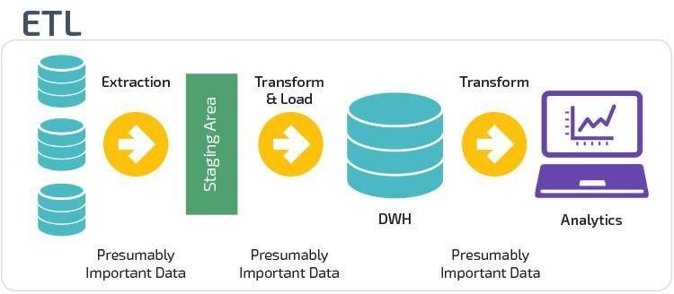

**1. Data Extraction :-**

In this step, I had retrieved data out of the data source for further processing of the data.

**2. Data Transformation :-**

In this step, I have eliminated all the null values and duplicate valuesand also some false values from my dataset and transformed some numeric values into date format.

**3. Data Load :-**

In this step, I had transformed data according to my project and I had alsocalculated the required data and created pivot tables after the data load.

**Tableau Prep**

Tableau Prep is an ETL tool (Extract Transform and Load) that allows you to extract data from a variety of sources, transform that data, and then output that data to a Tableau Data Extract (using the new Hyper database as the extract engine) for analysis.

Tableau Prep helps you examine and visualize your data, enabling you to do the following:

**1. Connect and extract data:**

**2. Understand data:**

* Number of columns/fields in your data
* Number of records
* Data types of fields
* Number of distinct values in a field
* Visualize how the data is distributed by field

**3. Identify issues and errors:**

**4. Clean/Modify and Filter data:**

Remove fields

Modify/change values in a field

Split fields

Aggregate data

Filter out data

Enhance data

Add calculated fields

Join additional data

Union additional data

 Output resulting data for use in analysis and reporting

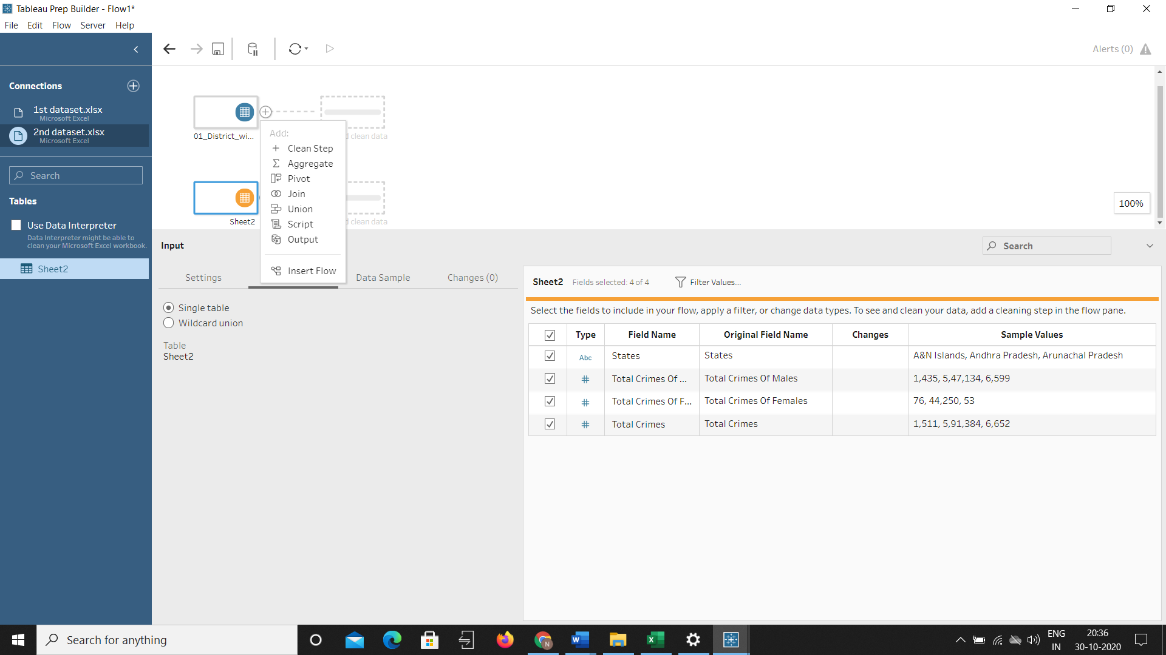

**Removing null values from dataset :**

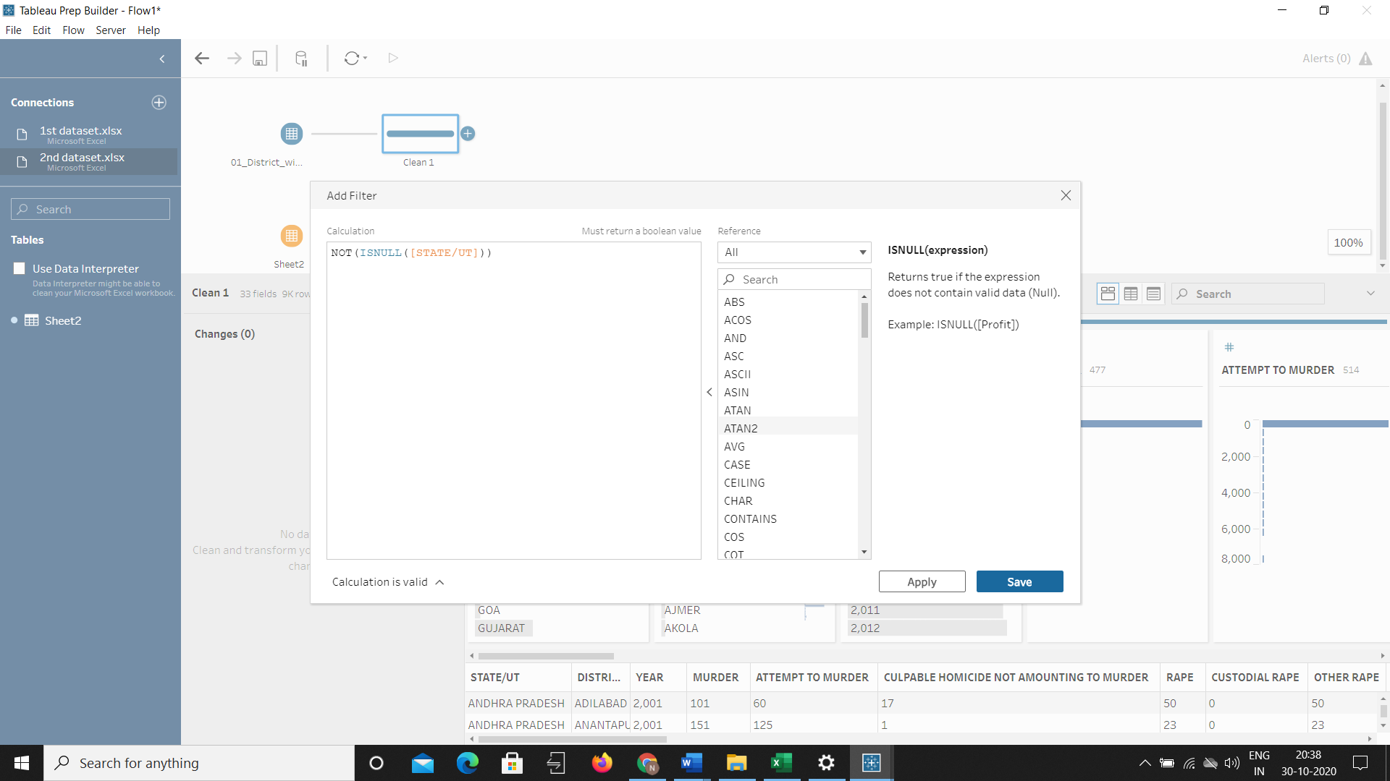

**Change datatype from number to date format :**

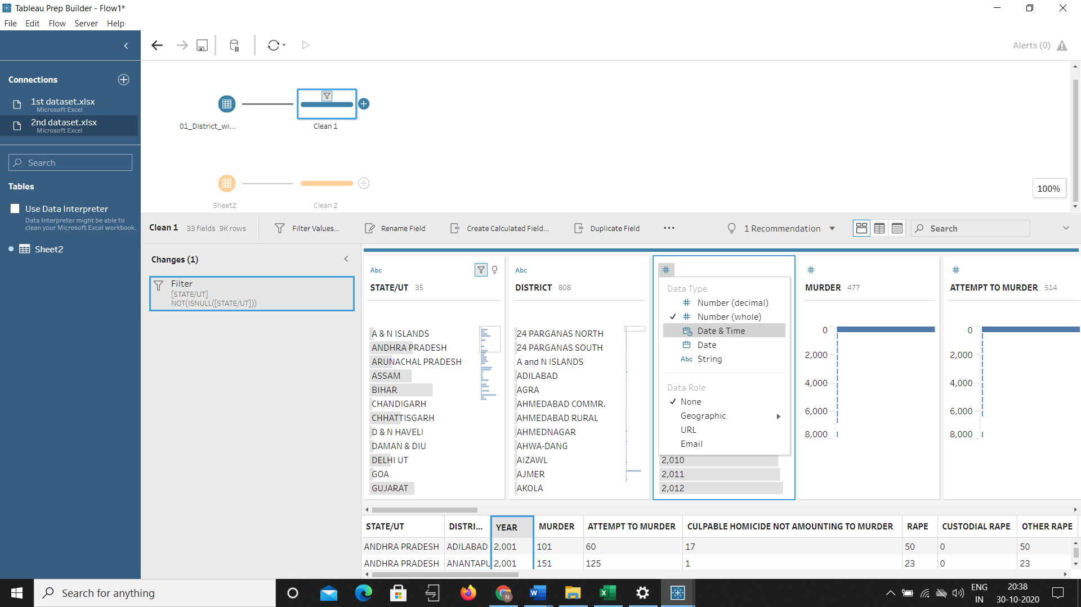

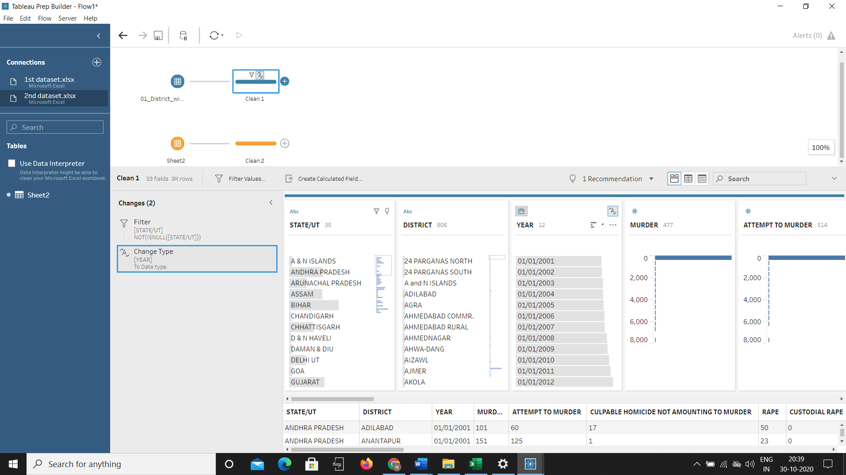

**Changes and output of cleaned data :-**

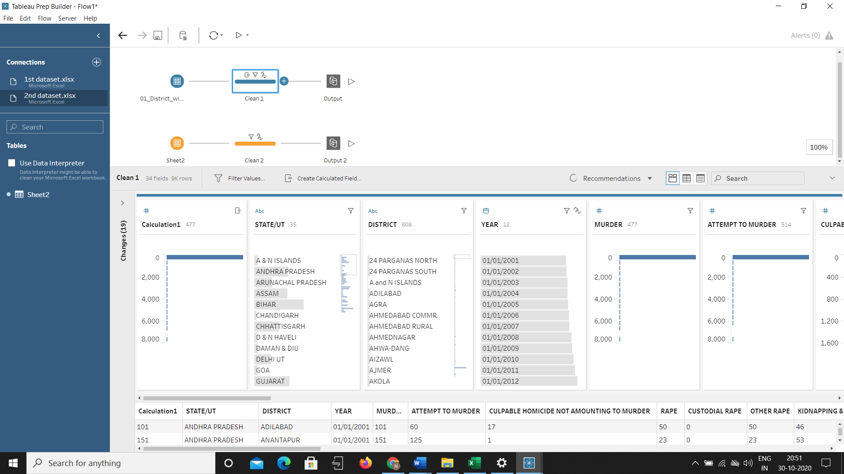

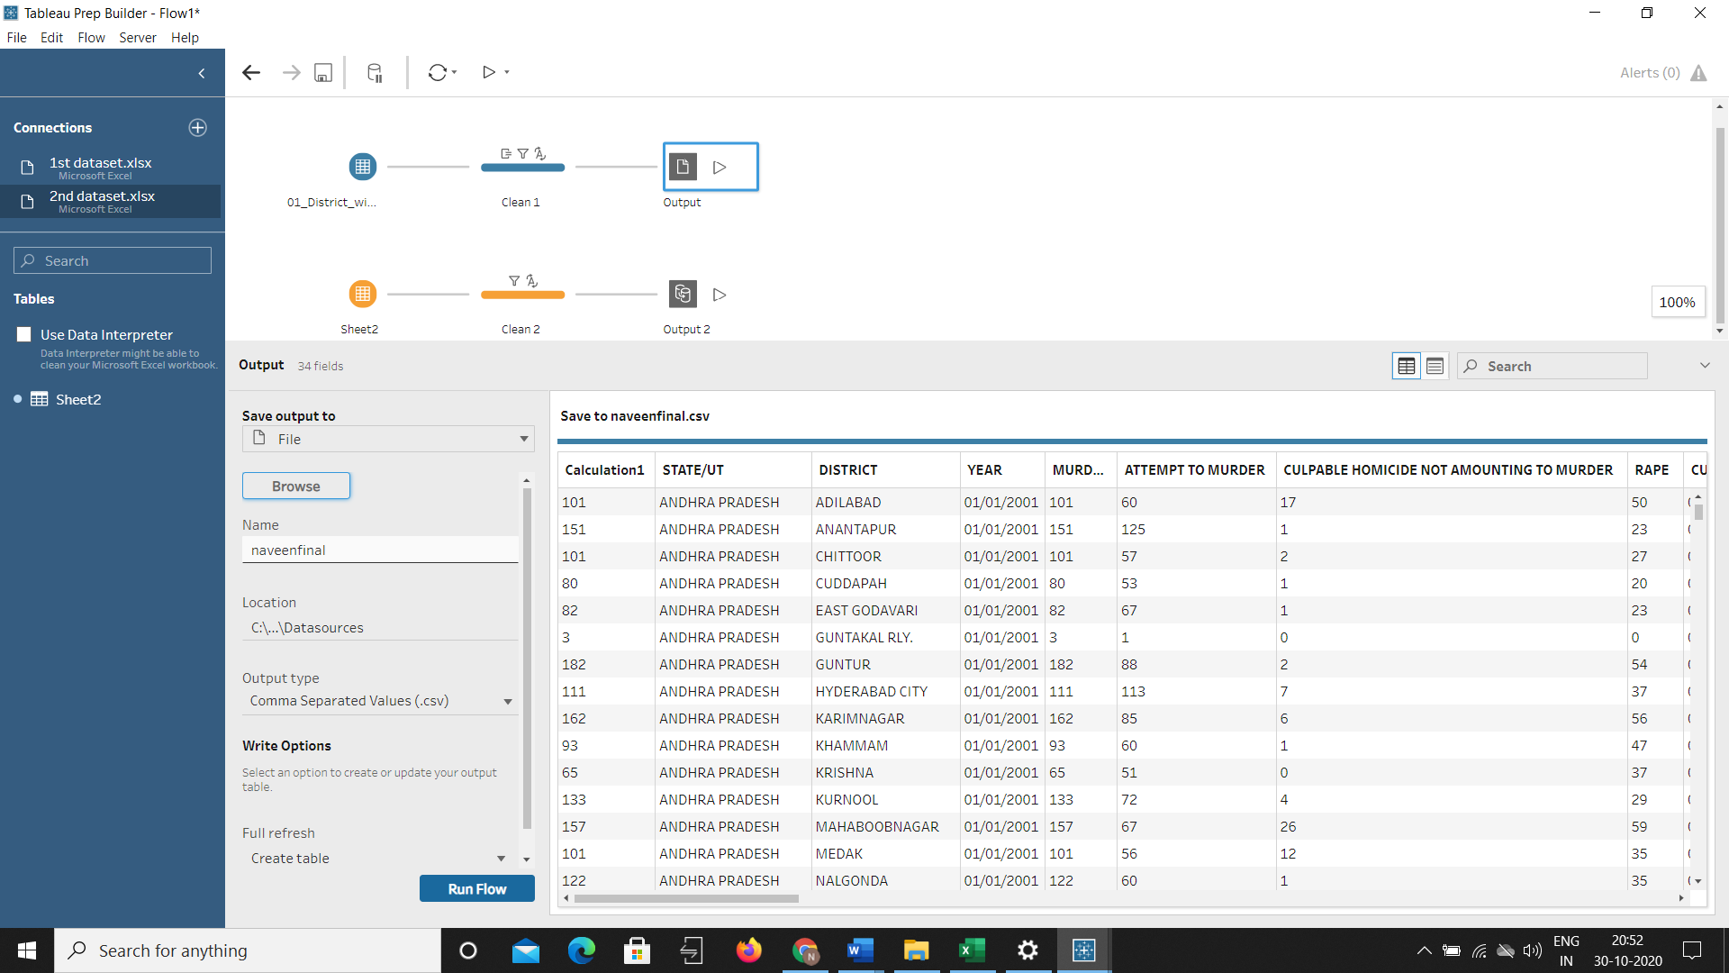

**Dataset :-**

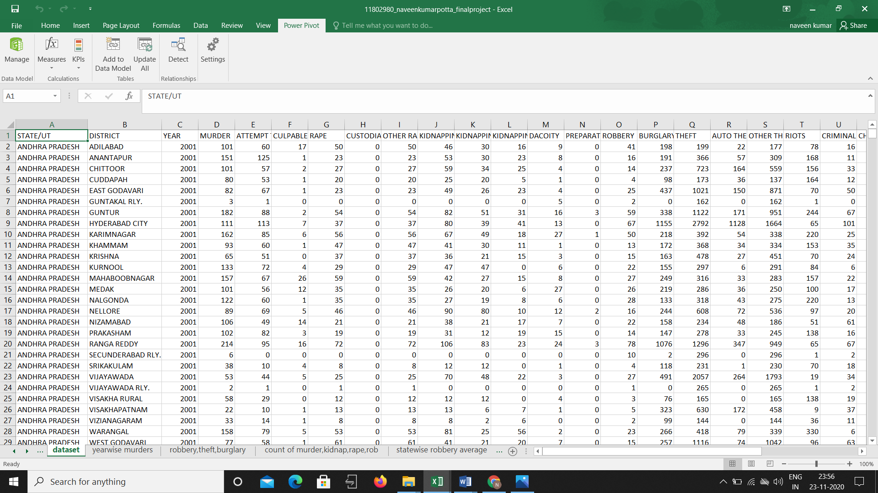

**Analysis Of Datasheet :-**

**Introduction:**

Data analysis is a process of inspecting, cleansing, transforming, and modeling data with the goal of discovering useful information, informing conclusions, and supporting decision-making. Data analysis has multiple facets and approaches, encompassing diverse techniques under a variety of names, while being used in different business, science, and social science domains.

The process of data analysis:

* Data requirements
* Data collection
* Data processing
* Data cleaning
* Modeling and algorithms

**What is a dashboard?**

An Excel dashboard is one pager (mostly, but not always necessary) that helps managers and business leaders in tracking key KPIs or metrics and take a decision based on it. It contains charts/tables/views that are backed by data.A dashboard is often called a report, however, not all reports are dashboards.

Here is the difference:

* A report would only collect and show data in a single place. For example, if a manager wants to know how the sales have grown over the last period and which region were the most profitable, a report would not be able to answer it. It would simply report all the relevant sales data. These reports are then used to create dashboards (in Excel or PowerPoint) that will aid in decision making.
* A dashboard, on the other hand, would instantly answer important questions such which regions are performing better and which products should the management focus on. These dashboards could be static or interactive.

**Visualization of objectives :-**

Data visualization is the graphical representation of information and data. By using visual elements like charts, graphs, and maps, data visualization tools provide an accessible way to see and understand trends, outliers, and patterns in data in the world of Big Data, data visualization tools and technologies are essential to analyze massive amounts of information and make data-driven decisions.

Common general types of data visualization:

* Charts
* Tables
* Graphs
* Maps
* Infographics

**Year-wise murders :-**

In this we can find the murders in India year-wise with respective to whole India or with respective to state-wise and district-wise using pivot table.

**Visualization :**

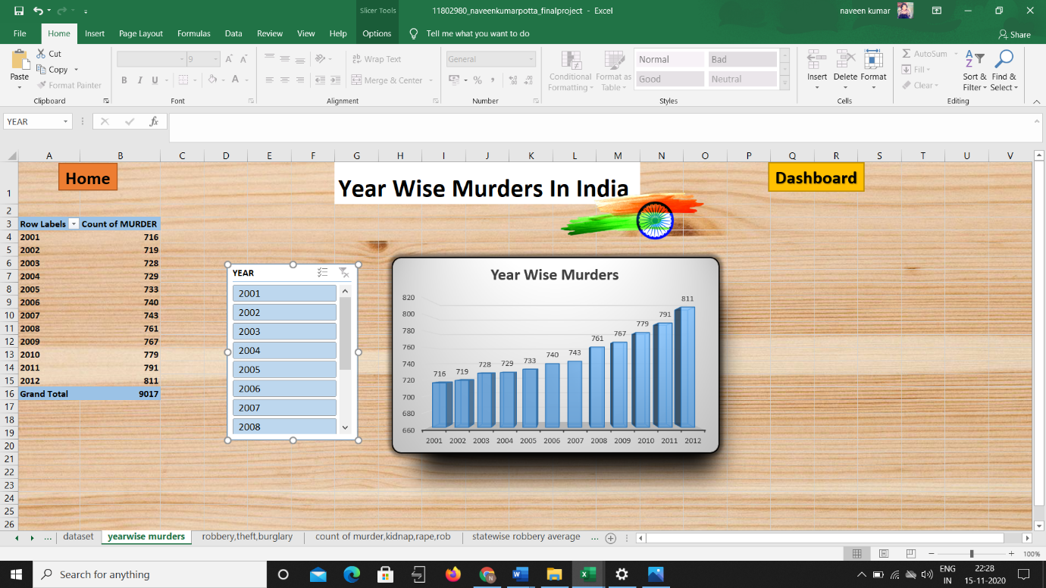

**Percentage of Robbery, Theft, Burglary :**

In this using pivot table we can find the comparisons of different percentage of robberies, theft and burglaries according to year, state-wise and also along with district-wise.

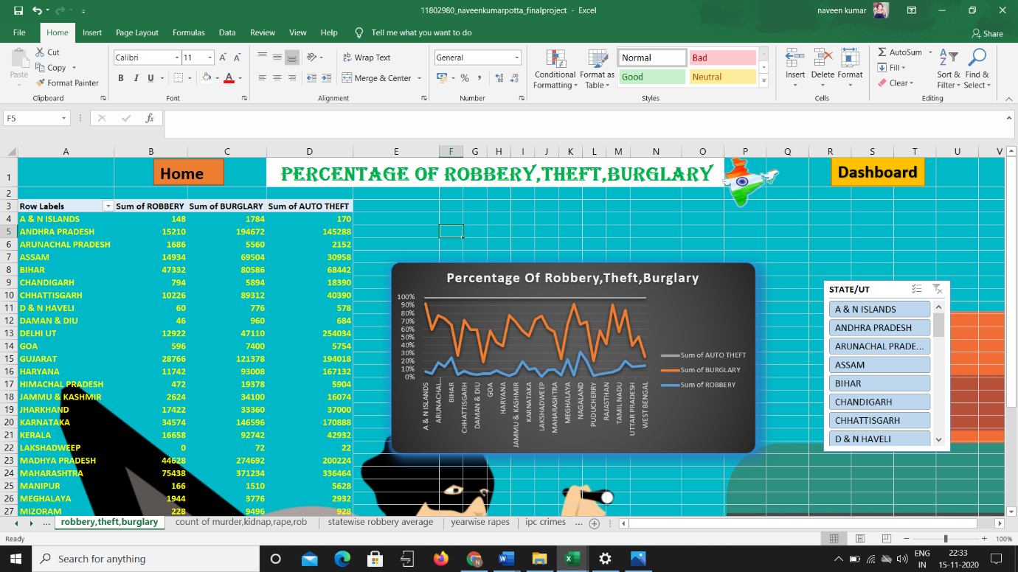

**Count Of Crimes (murder, kidnap, rape, robbery):**

Using pivot table we can find the count of crimes year-wise and also state-wise and also district-wise. In this crimes include murder, kidnap, rape and robbery.

**Visualization :**

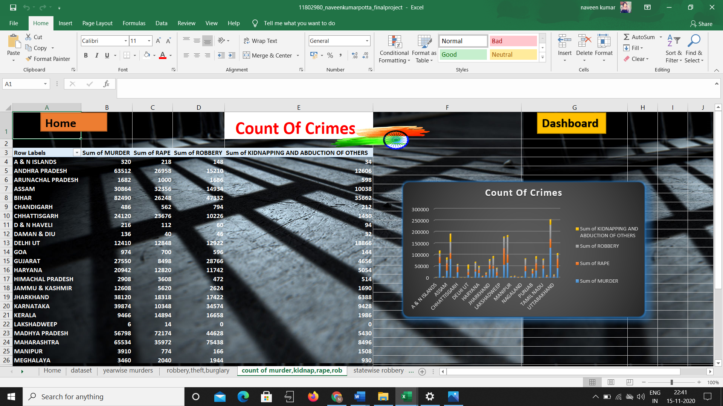

**Average Robbery State-wise :-**

In this by using pivot table we can find the average robberies happened in states and districts with respective to the various years.

**Visualization :**

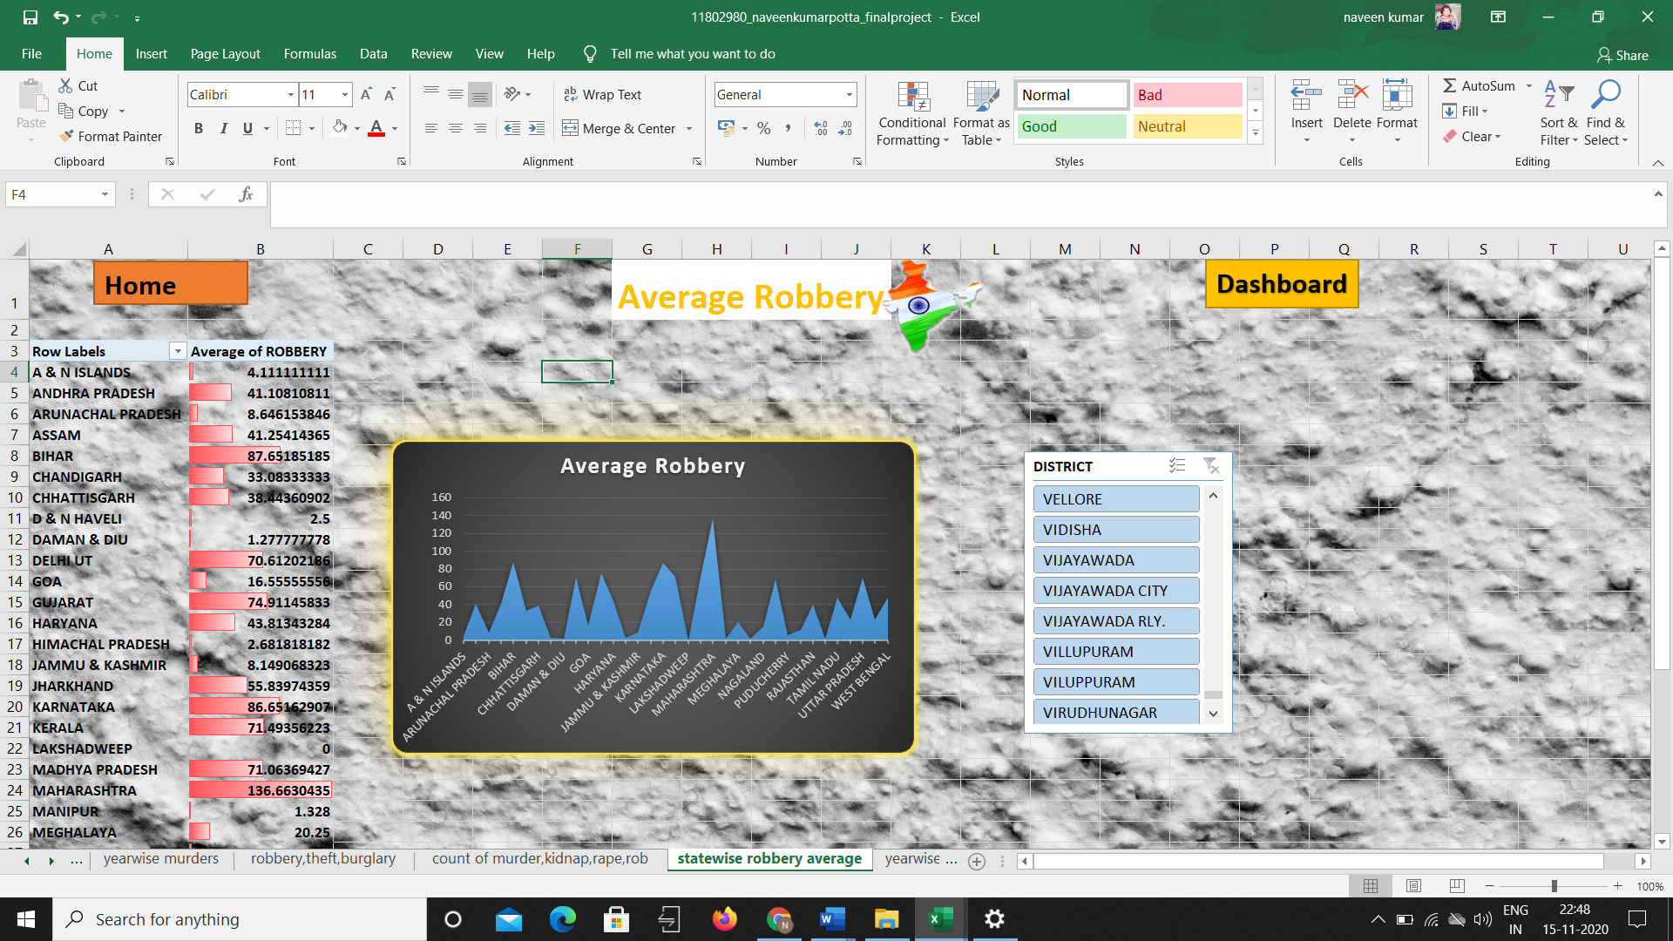

**Count Of Rapes :**

In this we can find the number of rapes happened in states or districts with respective to the corresponding year. In this I used pie chart for the data visualization.

**Visualization :**

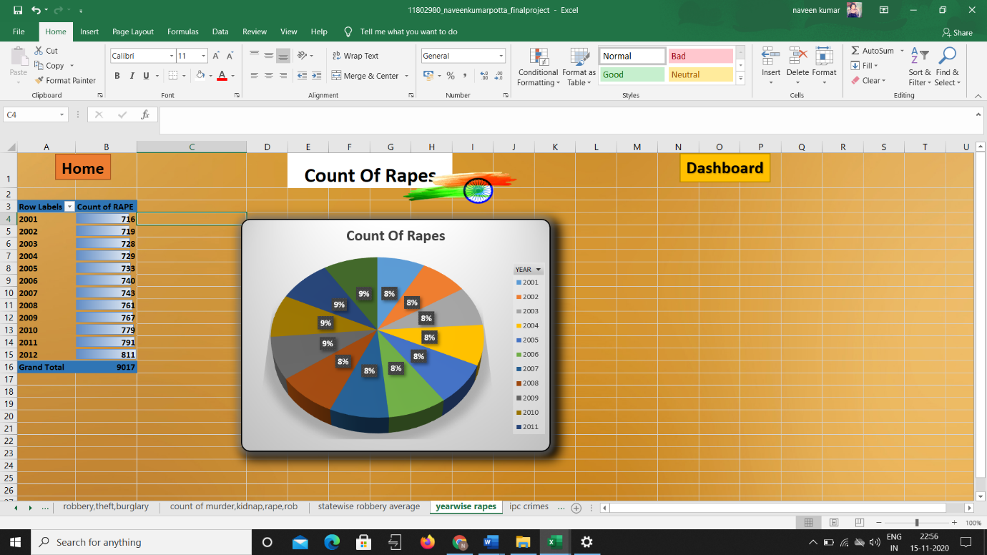

**IPC Crimes:**

In this objective, I used power-pivot and constructed a power-pivot table based on the total IPC crimes that happened with corresponding to the states.

**Visualization :**

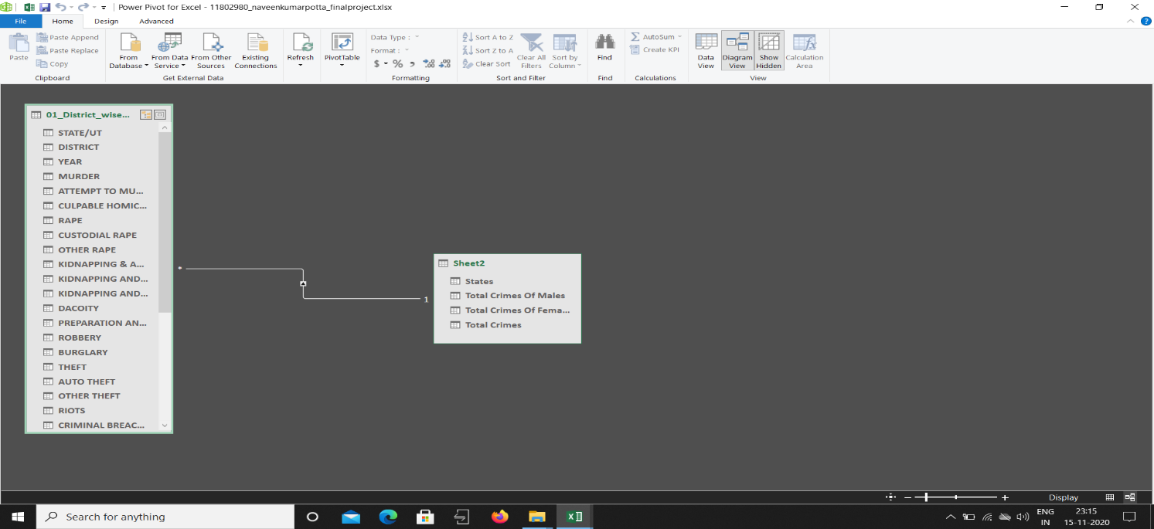

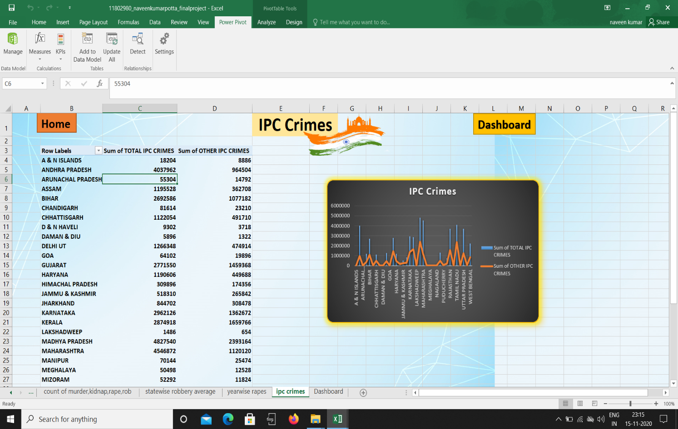

**Analysis Result :-**

**Home:**

It is the main page where a visitor or anyone can easily navigate to the dashboard from the home page we see, and it may also serve as a landing page.

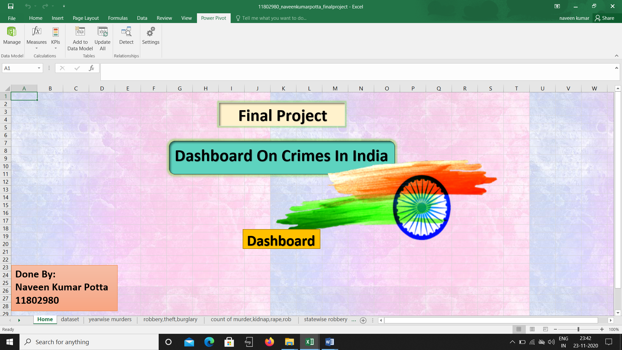

**Dashboard :**

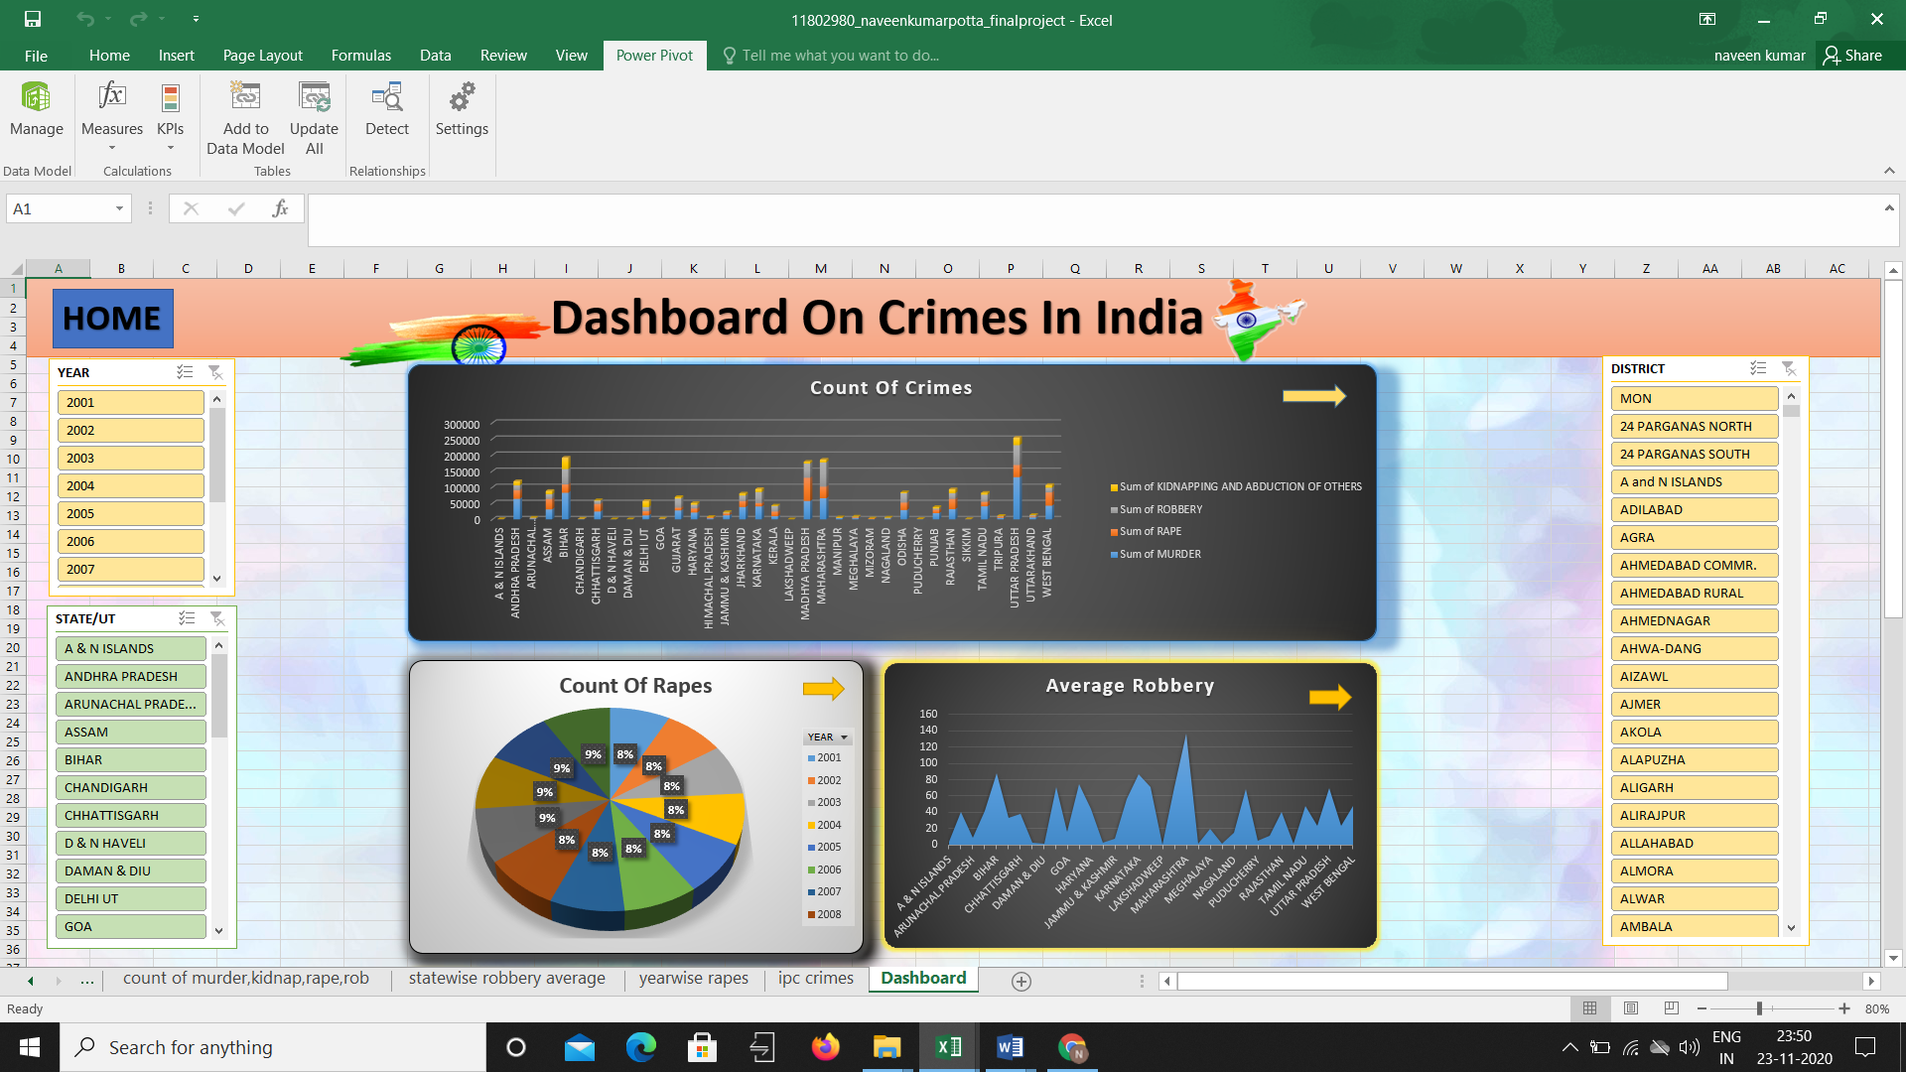

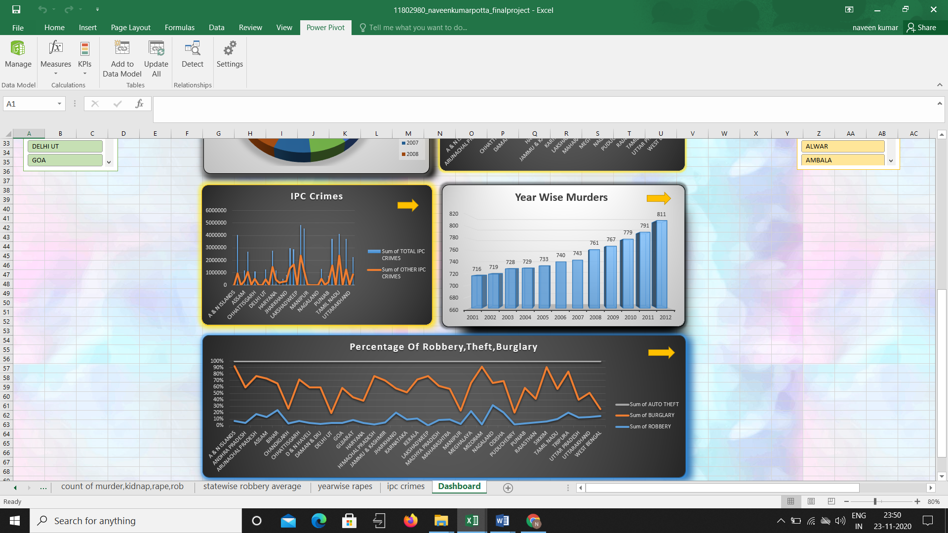

**Specific Requirements, functions and formulas:**

We use different formulas for data cleaning, data processing and modelling and algorithms.

Main function of excel that I have used are :

* Power pivot
* Pivot table
* Hyperlink
* Buttons
* Conditional formatting
* Create graph using power pivot
* Create relation between different table
* Function analyser (Slicer)
* Different types of graph

**Slicers :**

Slicers provide buttons that you can click to filter tables, or PivotTables. In addition to quick filtering, slicers also indicate the current filtering state, which makes it easy to understand what exactly is currently displayed.

This dashboard has 3 slicers which works as filters and helps us to select multiple options at a time. They are :

* 1) Year slicer
* 2)District slicer
* 3)State / Union territory(UT) slicer

**Year slicer :**

This slicer contains all the years from 2001 to 2012 and the slicer acts like a filter to select the desired year or years based on our need.

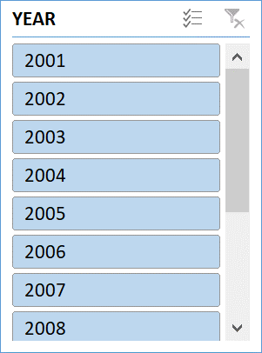

**State / UT slicer :**

This slicer contains list of all the states and union territories of India and based upon our need we can select any state and it will filter and displays the desired output based upon our input.

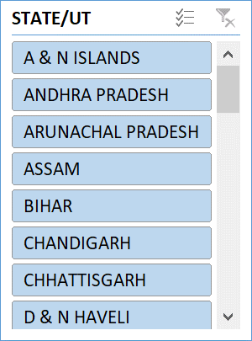

**District slicer :**

In this slicer it contains all the districts of all the states of India. We can select our desired district of any district and we can analyse data easily according to the district.

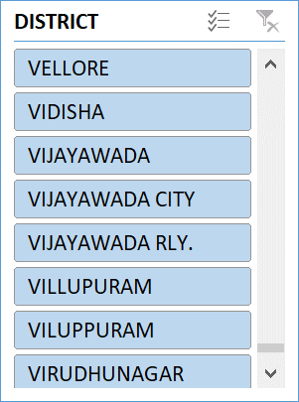

**Buttons :**

In this dashboard I used buttons for the hyperlink purpose. I have created a hyperlink for the buttons and after that when we click on the buttons it will go to the location that we given in hyperlink.

In this if we click home button then it will open the home page.

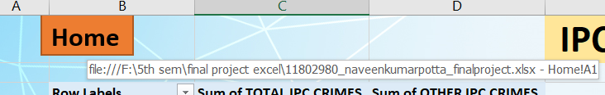

In this if we click on dashboard button then it will opens the dashboard sheet.

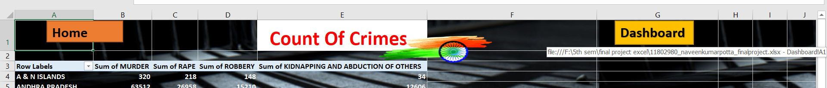

In this if we click on the arrow symbol then it opens the sheet where the pivot table was created. I assigned a hyperlink to this arrow symbol.

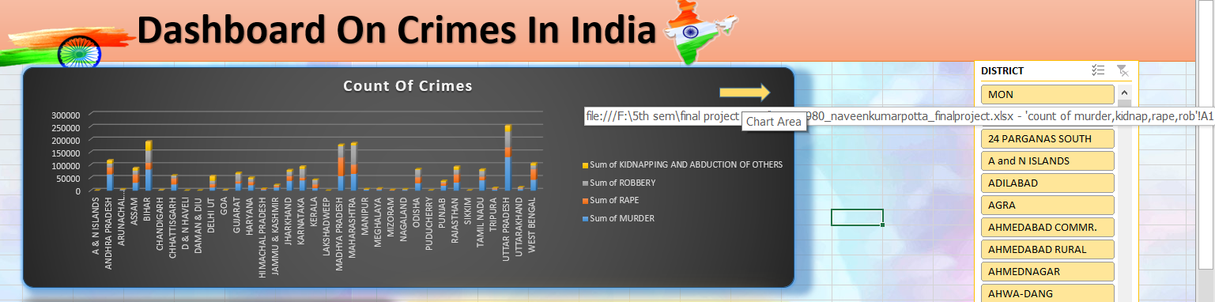

**Future Scope:**

Once one have completed a course in this field, one can opt job in various areas such as Forensic Department, Police, Research area, Medical Hospitals, CBI, Court, FBI, Crime Laboratories, Private Hospitals, Colleges, Institutions, MNCs (legal matters), Prison Reforms Programs and many others  
  
Read more at: <https://www.careerindia.com/courses/unique-courses/what-is-criminology-scope-and-career-opportunities-020065.html>. 

**References:**

* WIKIPEDIA.com
* Crime in India.com
* Google.com

**Bibliography:**

* **Source:** <https://shodhganga.inflibnet.ac.in/bitstream/10603/45012/15/15_bibliography.pdf>
* <https://hosted.law.wisc.edu/wordpress/sharafi/bibliography/>

**Thank**

**You**